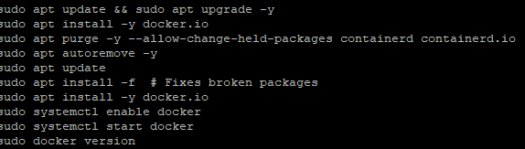

VER=$(curl -s https://api.github.com/repos/Mirantis/cri-dockerd/releases/latest | grep tag_name | cut -d '"' -f 4 | sed 's/v//')

wget https://github.com/Mirantis/cri-dockerd/releases/download/v$VER/cri-dockerd-$VER.amd64.tgz

tar xvf cri-dockerd-$VER.amd64.tgz
sudo mv cri-dockerd/cri-dockerd /usr/local/bin/
sudo chmod +x /usr/local/bin/cri-dockerd

sudo wget -P /etc/systemd/system/ https://raw.githubusercontent.com/Mirantis/cri-dockerd/master/packaging/systemd/cri-docker.service
sudo wget -P /etc/systemd/system/ https://raw.githubusercontent.com/Mirantis/cri-dockerd/master/packaging/systemd/cri-docker.socket
sudo sed -i 's|/usr/bin/cri-dockerd|/usr/local/bin/cri-dockerd|' /etc/systemd/system/cri-docker.service

sudo systemctl daemon-reload
sudo systemctl enable cri-docker.socket
sudo systemctl start cri-docker.socket
sudo systemctl status cri-docker.socket
/usr/local/bin/cri-dockerd –version
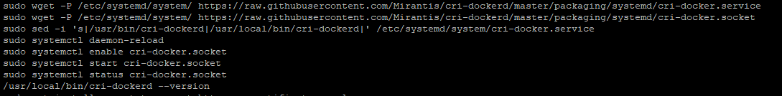
sudo apt install -y apt-transport-https ca-certificates curl gpg
curl -fsSL https://pkgs.k8s.io/core:/stable:/v1.31/deb/Release.key | sudo gpg --dearmor -o /etc/apt/keyrings/kubernetes-apt-keyring.gpg

echo 'deb [signed-by=/etc/apt/keyrings/kubernetes-apt-keyring.gpg] https://pkgs.k8s.io/core:/stable:/v1.31/deb/ /' | sudo tee /etc/apt/sources.list.d/kubernetes.

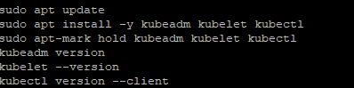
sudo apt update
sudo apt install -y kubelet kubeadm kubectl
sudo apt-mark hold kubelet kubeadm kubectl

kubectl version --client
kubeadm version
kubelet –version

sudo kubeadm init --pod-network-cidr=10.244.0.0/16 --cri-socket unix:///var/run/cri-dockerd.sock --apiserver-advertise-address=172.31.11.243
ls -a
mkdir -p $HOME/.kube

sudo chown $(id -u):$(id -g) $HOME/.kube/config
sudo kubectl get nodes
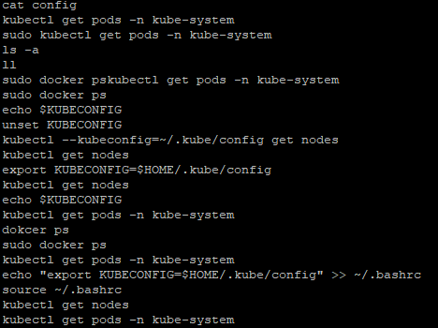

kubectl apply -f https://raw.githubusercontent.com/flannel-io/flannel/master/Documentation/kube-flannel.yml
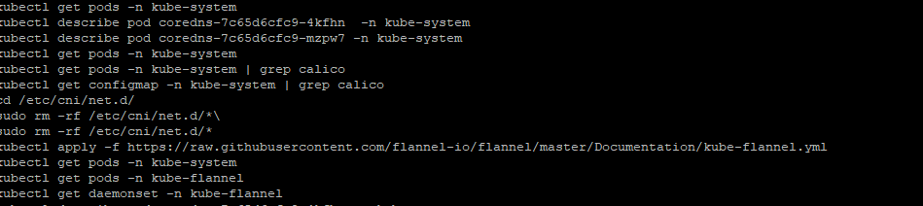
kubectl get pods -n kube-system
kubectl get pods -n kube-flannel
kubectl get daemonset -n kube-flannel
kubectl describe pod coredns-7c65d6cfc9-4kfhn -n kube-system
kubectl get nodes
kubectl describe node k8s-master-node
sudo ls -l /etc/cni/net.d/
sudo rm -f /etc/cni/net.d/10-calico.conflist /etc/cni/net.d/calico-kubeconfig
sudo rm -f /etc/cni/net.d/10-flannel.conf
sudo ls -l /etc/cni/net.d/
kubectl delete -f https://raw.githubusercontent.com/flannel-io/flannel/master/Documentation/kube-flannel.yml
kubectl apply -f https://raw.githubusercontent.com/flannel-io/flannel/master/Documentation/kube-flannel.yml

kubectl get pods -n kube-flannel
kubectl delete pod -n kube-system coredns-7c65d6cfc9-4kfhn coredns-7c65d6cfc9-mzpw7
kubectl get pods -n kube-system
kubectl get nodes -o wide
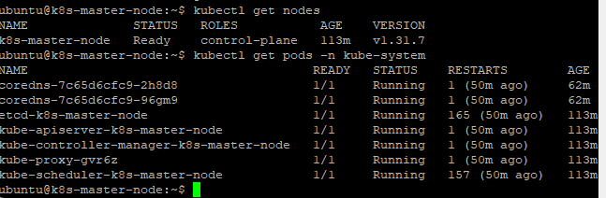

Jenkins

